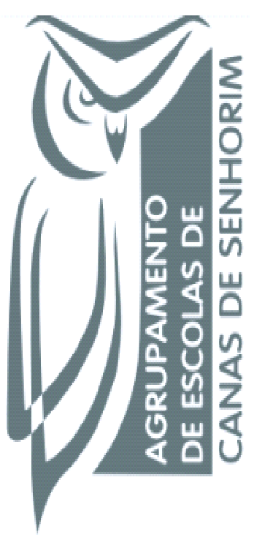

Managing for @ School of Success
2nd Short Term Joint Staff Training Event - “School Autonomy”
07th to 11th November, 2016. Hertogenbosh, Netherlans;

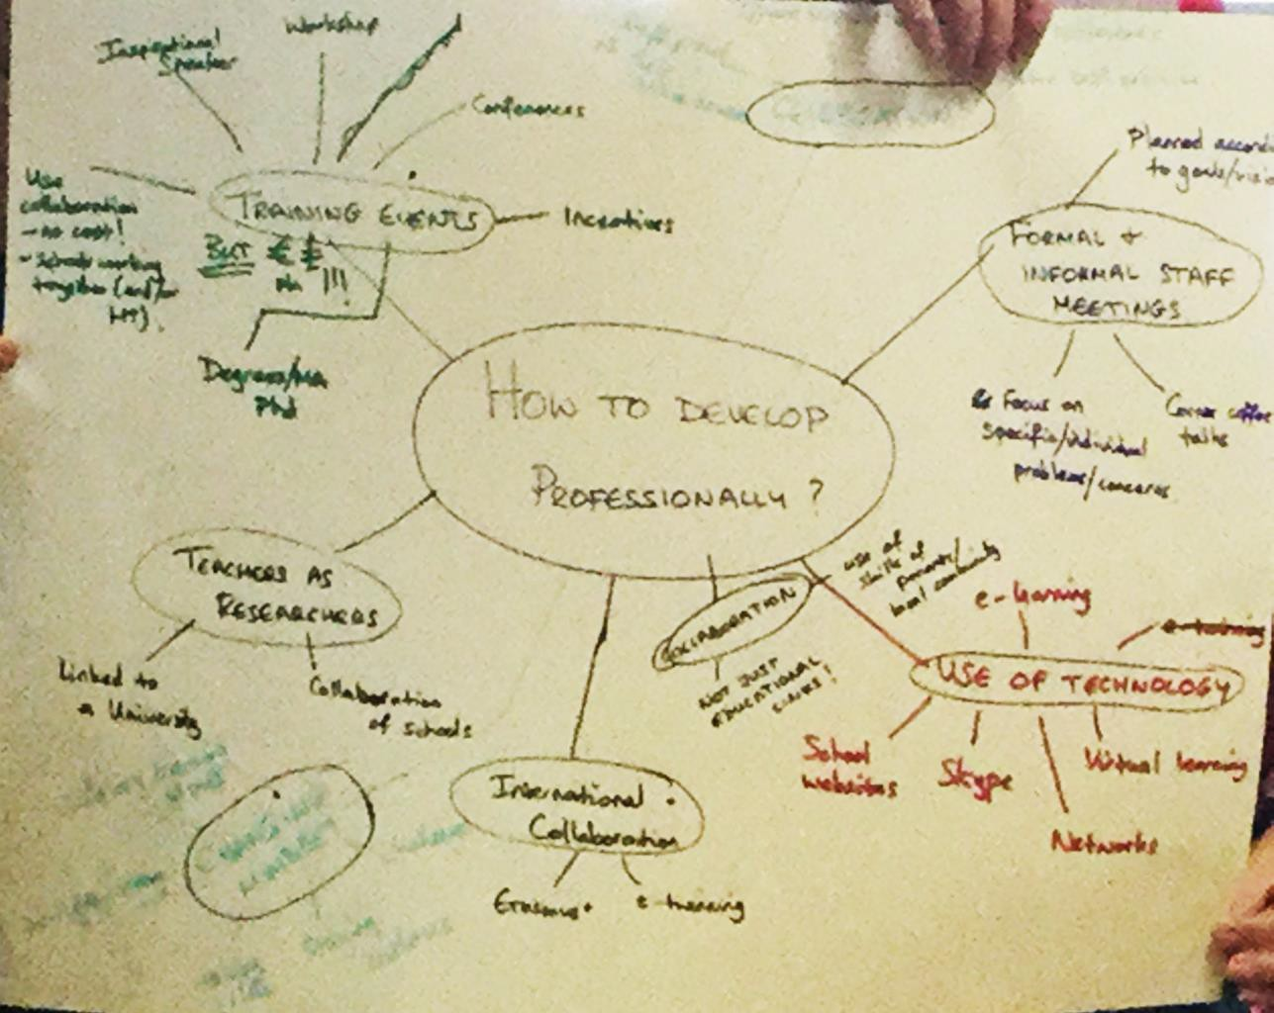

This work is licensed under a Creative Commons Attribution-NonCommercial 4.0 International License.

